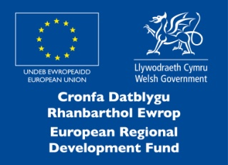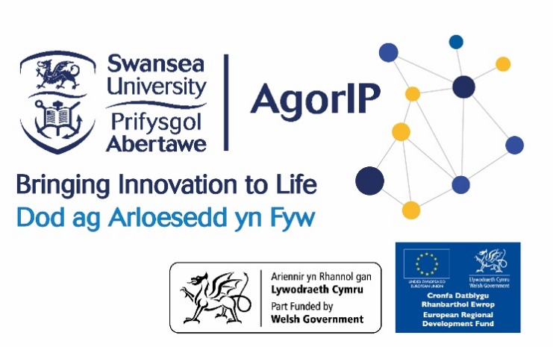

**AgorIP NHS Commercial Support Application Form**

Please submit your proposal to [agorip@swansea.ac.uk](mailto:agorip@swansea.ac.uk) by 23rd October 2020.

**1. Title of the project:**

**2. Principal applicant details;**

* **Health Board & Department:**
* **Name:**
* **Email address:**
* **Phone number:**

**3. Do you have any external collaborators?** *Please tell us if you have any existing collaborators.*

**4. How can AgorIP accelerate your commercial prospect?** *Why do you need AgorIP support?*

*Please do not exceed 150 words.*

**5. Aims of the project and rationale**

*Provide a clear description of the aims of the proposed commercial activity, why you are seeking support and what you are trying to achieve. What is the technology? What problem are you trying to solve? Explain the idea/invention/software (purpose, key novel elements etc.) What are you hoping to build? (device/prototype, service, process/method, software etc.)*

*Please do not exceed 250 words.*

**6. Proof of Concept**

*What proof do you have to show that the technology/your idea is valid?*

*Please do not exceed 100 words.*

**7. What is novel or unique about your idea/ technology?** *What is your USP (unique selling point)? What is the closest technology available on the market? Why it is superior to the products currently on the market?*

*Please do not exceed 250 words.*

**8. What is your commercial plan and timeline?**

*What are the start and end dates of the proposed work? Provide an indication of the schedule, starting November 2020 for the next six to nine months.*

|  |  |
| --- | --- |
| **Activity** | **Date** |
|  |  |
|  |  |
|  |  |
|  |  |
|  |  |

**9. Who will want this product/ idea?** *Have you talked to any potential customers/end users/licensees about this technology? If so, what was their response?*

*Please do not exceed 250 words.*

**10. Budget**

*Provide a clear breakdown of costs and the total amount requested. Please provide a brief justification – why do you need funds - for each budget line. Please explain how the spent will increase the potential of your commercial success.*

*Some of the eligible costs are as follows:*

* *Business/commercial mentors*
* *Market research*
* *Prototype development*
* *Demo video development*
* *Graphic design*
* *Story board*
* *IP protection*
* *Commercial engagement cost*
* *Other costs*

*Please see the eligibility criteria notes before completing this section.*

*Please note that,* ***any form of*** *staff and PC/ laptop costs are ineligible.*

|  |  |  |
| --- | --- | --- |
| Description of funds sought | Cost | Outcome of the spend |
|  | **£** |  |
|  | **£** |  |
|  | **£** |  |
|  | **£** |  |
|  | **£** |  |
|  | **£** |  |
| Total sum requested | **£** |  |